Template for the Establishment of a McMaster Research Centre or Institute (RCI)

Please provide the following documentation, in keeping with the Guidelines for the Governance and review of Research Institutes Centres Groups (mcmaster.ca)

To be recognized as a formal McMaster Centre or Institute, a proposal for consideration must be submitted to the Office of the Vice-President (Research) and approved by the following McMaster Committees and Governing Boards:

- Committee on Research Centres and Institutes (CRI)
- University Planning Committee (UPC)
- Senate
- Board of Governors (BofG)

The CRI will comprise the following: VPR (as Chair), the Provost (VP Academic), the Dean of Graduate Studies, the University Secretary, and the Faculty Deans relevant to the specific Institute or Centre. The CRI generally takes approximately two to three weeks to review and provide comments.

After CRI approval, the proposal is submitted to the other committees. Following proposal approval, paperwork to appoint a Centre/Institute Director should then be submitted following appropriate policies. For a listing of governance meeting dates, please visit: https://secretariat.mcmaster.ca/meetings/meeting-dates/

Proposal Outline/Template
Overview Please complete the “Overview” on page 2 of this document

Proposal Please complete a Proposal under the following headings (more details are provided on page 3):

    - Background
    - Objectives and Proposed Activities
    - Rationale for Establishment of the Research Centre or Institute
    - Criteria for expanding the membership beyond what is shown in the Overview
    - A detailed business plan that includes:
      - Financial needs
      - Anticipated and Secured sources of support
      - Space needs
      - Human resource needs of the Research Institute or Centre
The business plan should align with and expand upon that provided in Appendix A: Budget.
    - Organizational Structure - (see examples included in this document)

Appendix A Budget including costs and sources of funds

Additional appendices to be added could include:
- List of current funded research projects
- List of planned grant applications

Overview

Proposal for the Establishment of …. |  |  |  |  | Institute |  | Centre
Official Name of Research Institute or Centre
The RCI will report to which Faculty?
List all other Faculties that have a significant interest in the RCI and confirm they will be represented on the Governing Board
Core Members |  | The membership of the Research Centre or Institute (RCI) is integral to its mission. It is imperative to define at establishment what constitutes membership; what the obligations of membership are; and what roles members may play in the operations of the Centre or Institute. While the size of membership may vary for different Centres or Institutes, there is an expectation that the membership will be large enough that critical mass for impact may be reached. An updated membership list will be submitted annually to the RCI Governing Board through the annual reporting process.
Definition of Core member:

Obligations for Core Members:

Identify the potential operational roles assigned to core members (e,g., Director, Associate Director roles in EDI, operations, outreach etc.):

Name | Faculty | Expertise and potential roles in RCI operations
 |  | insert additional rows as required

Associate Members
Definition of Associate Member:

Obligations for Associate Members:

Name | Faculty or Institution (if external to McMaster) |  |  | Expertise
 |  |  |  | insert additional rows as required
Space Needs |  | Sq. Ft |  | New space required? |  |  |  |  |  | Yes |  | No
 |  |  |  | Location? |  |  |  |  |  | Confirmed |  | Proposed
 |  |  |  |  | Space cost allocation covered by lead Faculty? |  |  |  | Yes |  |  | No
 |  |  |  |  |  | If no, specify:
Plans for Organizational Review
 |  |  |  | Frequency of External:
In addition, the RCI will be required to report annually to the Governing Board

Please provide names below and check box to verify that approval has been obtained from each: |  |  |  |  |  |  |  |  |  |  | Check box
Department Chair/ Area Director
Faculty Dean or Director of Administration
Other (specify)

- Background: (Describe the research theme(s) that are central to the Centre or Institute. What events led to this proposal, and how does the RCI align with the strategic research plan):

- Objectives and Proposed Activities:

    - Objectives: (expand on the thematic research proposed; and explain how the impact of the RCI’s work will benefit stakeholders and be measured by the RCI. Ideally, provide goals for the next five years against which success of the RCI may be measured):

    - Proposed Activities: (the proposal must show how the collective membership of the RCI will generate research impact which is greater than that which would be generated by the sum of its’ parts. In other words, what value-add is the RCI bringing to the thematic research that could not be achieved by the members working in their individual research groups? The proposed activities must be such that this goal can be reasonably expected. It is not enough to explain that an RCI will house infrastructure, for example, that will be used by members to advance their research. That is the definition of a “Core Platform”. It is possible, however, to be a Core Platform and an RCI – but such an RCI/Platform is then required to show it is a Core Platform and an RCI):

- Rationale for Establishment of the Research Centre or Institute: (In this section it is necessary to explain the thematic research to take place, and what impact it will have on stakeholders.):

- Criteria for expanding the membership: (this should be linked to definition and obligations of membership):

- Detailed business plan (sustainability must be demonstrated):
- Financial needs:
- Discuss/explain operating budget and attach Appendix A (Budget template)
- What is the amount of funding required?

- Anticipated and secured sources of support:
- Start-up funds? Faculty commitments? External funds?

- Space needs:
      - Please expand on the detail from the “overview” page, identifying the existing or new space requirements for the Centre or Institute, noting whether the Faculty Dean has approved use of that space for this purpose.
      - Identify the plans for the location and coverage of the space costs. Has this been approved by the Faculty Dean?

- Human Resource needs:
- Explain how the day to day operations will be managed.
- Include faculty assistance or commitments
- Will there be hiring of employees?
- Use of students?
- Add detail regarding roles of research and administrative personnel

    - Organizational Structure: (If a potential inaugural director is named in the proposal, ensure that appropriate Senate Committee on Appointments (SCA) paperwork and governance approvals are submitted after Centre/Institute approval):

    - Director:
- An Institute and a Centre is led by its Director, who is normally appointed for a 5 year term.

    - Advisory Committee:
- The Director establishes an Advisory Committee (AC) whose purpose is to provide advice to the Director with regard to scientific or scholarly priorities and direction for the Institute or Centre. The AC is chosen by the Director, and is consulted at least every two years, or more frequently at the discretion of the Director.

- Committee members:
- Please list Committee members who have agreed to serve or who will be approached.

Governing Board and Role in Annual Review:
(While the following provides guidelines for membership of Governing Boards, it is recognized that membership of the Governing Board may fall outside of these guidelines. Proposals are encouraged to work with the Office of the VPR when confirming the membership of the Board.)

For Institutes: Final authority for all matters regarding the direction and operation of the Institute will rest with the Institute’s Governing Board (GB). The Institute’s GB is normally chaired by the VPR or appropriate Dean (or designate), and is composed of the Deans (or designates) of the Faculties most affected by the success or failure of the Institute. The GB should monitor the activity of the Institute every year.

For Centres: Final authority for all matters regarding the direction and operation of the Centre will rest with their Governing Board. The Centre’s GB is normally chaired by the appropriate Dean (or VPR) or designate, and is composed of the Chairs (or designates) of the Departments most affected by the success or failure of the Centre. The GB should monitor the activity of the Centre every year.

Organizational Charts: see examples on next page

Reporting Lines for University Institutes
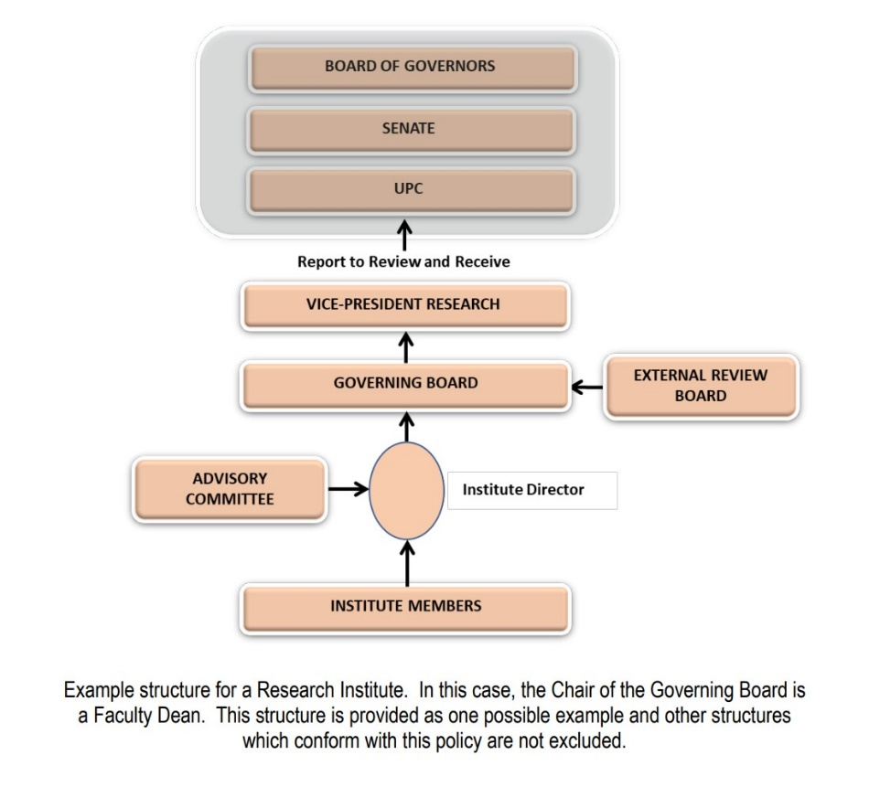

Reporting Lines for University Centres:

