McMasterREM (MacREM)

Reviewer

MREB/SREC Training Manual

Helpdesk: 905-525-9140 ext. 23142
Email: ethicsoffice@mcmaster.ca

Table of Contents
1. About MacREM 3
1.1 Target Audience 3
1.2 Internet Settings 3
1.3 Technical Support 3
2. Getting Started 4
2.1 Access the System 4
2.2 Accounts 4
2.3 How to Log In 4
3. Navigating the MacREM System 4
3.2 The Navigation Menu 5
4. The Review Process 6
4.1 Notification of Application Ready for Review 6
4.2 Accessing the Application for Review 7
4.3 Reviewing the Application 8
4.3.1 Reviewing the Application in PDF or Document Download 9
4.4 Adding Comments 9
4.4.1 Panel Comments 10
4.4.2 Form Comments 11
4.4.3 Editing Comments 12
4.4.4 Reviewing Comments Made by Others 13
4.4.5 The Letter from the Chair to Researchers 13
4.4.6 Submitting a Review 14
4.4.7 After a Review is Submitted 15
4.4.8 Writing Panel Comments Best Practices 17
4.4.9 Conflict of Interest 17
4.4.10 Confidential Review Comments 18
5. Additional Information 18

1. About MacREM

The new system was purchased from Infonetica Ltd, which specializes in research management, ethics management, ethics approval and compliance training solutions. It is the same system currently in use by the Hamilton Integrated Research Ethics Board (HiREB), but there is currently no shared login access. The system we are calling McMaster Research Ethics Manager (MacREM) is a web-based electronic platform for conducting research ethics reviews and is built using modern infrastructure that exhibits a vast set of features, while maintaining an easy-to-use interface.

HIREB has been using this system since 2014. Western University uses Infonetica, as well as the Ontario Cancer Research Ethics Board, and several other research hospitals in Ontario. Clinical Trials Ontario (CTO), for which HIREB acts as the REB of record, uses the software for multi-centred clinical trial review. CTO’s system CTO Stream has been developed in partnership with Infonetica. An Ontario wide group of users of the Infonetica system meet to share and discuss issues that has resulted in ongoing improvements.

Target Audience

This guide is intended for all MacREM Users who access the systems as an REB Reviewer. The guide will provide useful information about how to navigate the online application system. This user guide is appropriate for reviewers on Student Research Ethics Committees (SRECs) the only difference being the labelling of the tiles and actions buttons, or the user interface.

Internet Settings

MacREM supports the latest versions of the following browsers:
- Microsoft Edge
- Mozilla Firefox
- Google Chrome
- Apple’s Safari
MacREM uses pop-ups. You will need to configure your browser to ensure MacREM pop-ups are allowed. MacREM does not support the Epic browser and the TOR browser has not been extensively tested.

Technical Support

Email – macrem@mcmaster.ca
ethicsoffice@mcmaster.ca
Phone – 905-525-9140 ext. 23142

2. Getting Started

2.1 Access the System

To access the system go to: https://macrem.mcmaster.ca The actual login link is in the upper right corner. Or, just click the big login button! Next, contact the ethics office that you have created an account and they will assign you as a reviewer to a committee.

2.2 Accounts

Reviewers login using a different URL from applicants. That is why they must create an applicant account first in order to register with the system. Once registered as applicants, the MacREM administrators can then access your account and assign you as a Reviewer.

2.3 How to Log In

Once you have contacted the Ethics Office and they have assigned you a committee and a role as a Reviewer, you need to go this special link for reviewers only to login to see the applications that been assigned to your board or committee (or to you specifically): https://macremreview.mcmaster.ca

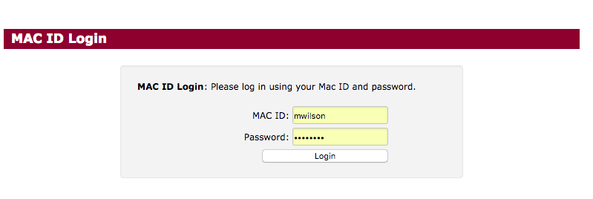

3. Navigating the MacREM System

Upon logging into MacREM, you will be directed to the Work Area. The Work Area is your home page, where you will find all current pending notifications, new projects for reviews and a list of upcoming meetings you are scheduled to attend.

3.1 Work Area
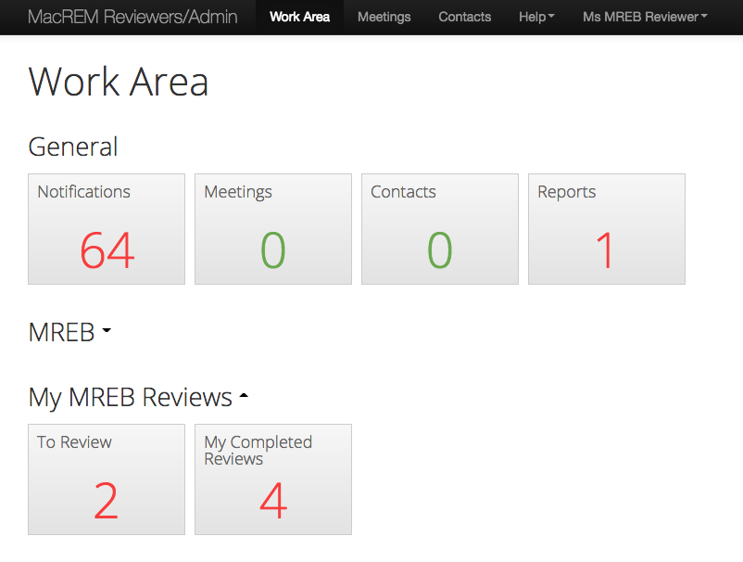
Navigation Menu

3.2 The Navigation Menu

The Navigation Menu (illustrated above) will always be visible at the top of the page, regardless of where you are in the system, and includes links to:

- Work Area – takes you to the Work Area / home page
- Meetings – allows you to view upcoming meetings you are scheduled to attend
- Contacts – takes you to the Contacts page for a list of personal contacts
- Help – the help bar links to:
- Help – Provides training materials for quick reference
- FAQ – Links to Frequently Asked Questions (Mostly about MacREM)
- Update History – shows the most current version of the software being used by the MacREM system
- About – Provides information about the McMaster Research Ethics Board (MREB)
- Contact Information – Provides quick access to contact information for the MREB Office of Human Research Ethics.
- Account Settings – clicking your name on the right-hand side of the Navigation Menu allows you to:
- Change password (no need as you will be using MacID)
- Update Personal Information
- Logout

4. The Review Process

4.1 Notification of Application Ready for Review

1. You will receive an email from donotreply@infonetica.net indicating there is an application ready for your review in MacREM. There will be a link in the email that when clicked will take you directly to the application to review, if you were already logged in.
2. When you log into MacREM, you will notice two things:
- A number in your notification tile indicating you have a notification awaiting action.
- A number in either “MREB Full Board” or “My MREB Reviews – To Review” tile, which means you have a study ready for your review.
3. You will also be able to access PDFs of the review sent by the Chair to the researchers on the protocol you have reviewed.

4.2 Accessing the Application for Review

1. Clicking the number count in the ‘To Review’ tile will take you to a list of applications awaiting their review. In the illustration below, this is what you will see when you click on an application awaiting review:

2. Click the application requiring review.
3. The ‘Timeline View’ page will appear; this page is a summary of what has
happened so far in the application. This timeline is actually for the second one.

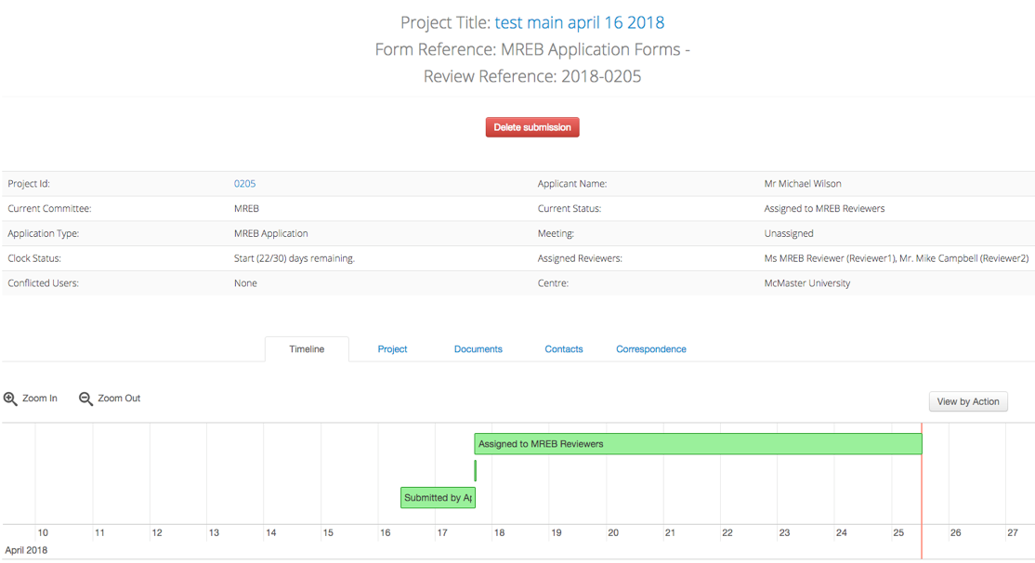

4. To review the application, click ‘Review Application’ in the action toolbar with the magnifying glass (on the left-hand side of the screen).
- If you would rather review a specific document first (as e.g., the protocol or Letter of Information), you can click on the ‘Documents’ tile (as illustrated above).
5. Begin by clicking the first questions or pages in Section 1.

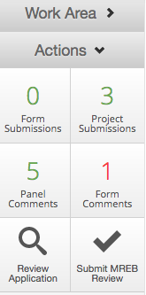

4.3 Reviewing the Application

1. When you are in the application, you can navigate it by using the ‘Previous’ and ‘Next’ buttons.
2. Clicking the ‘Navigate’ or ‘Timeline’ will bring you back to the Timeline Page.

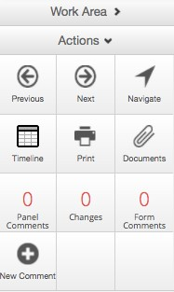

4.3.1 Reviewing the Application in PDF or Document Download

Instead of reviewing the application by navigating page by page and downloading uploaded attachments as they are presented, the other method is to Print the application or download all the uploaded attachments. Please note the Print and Documents button in the above image. In the Documents view there is Download All as PDF feature that combines both the application and the attachments in one PDF. You don’t necessarily have to print a paper copy using the Print button. On most computer systems, clicking the Print button will first generate a PDF. Reviewing from a PDF is already familiar to most reviewers. Downloading provides options to download all as a PDF, as a zip file, or individually. It takes a minute to download and print – go brew a coffee in the meantime.

Disclaimer: Download All as PDF some renders text in Word documents with incorrect formatting, missing sentences, huge fonts, incomplete tables, etc. This doesn’t happen all the time, but in any respect, the master version should be the Download All (a zip file) or individual download to review the whole document.

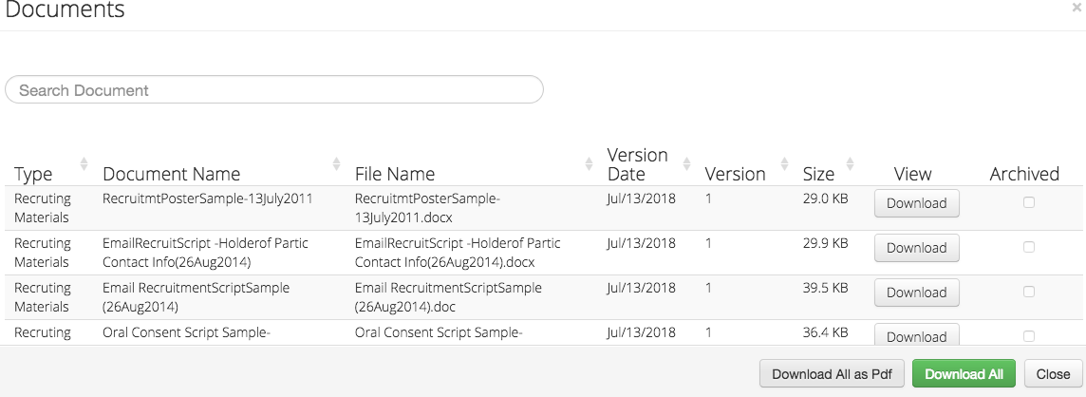

4.4 Adding Comments

To enter your review, you will need to add a comment. There are two kinds of comments into MacREM for an application for your review:

- Panel Comments – relate to a specific question
- Form Comments – relate to the overall application

Comments are visible to other members of the REB on the review, but are never visible to the researchers until the Chair sends the MREB feedback. However, the comments going to researchers are not attributed to individual MREB reviewers, but come from the Chair. Comments can be edited and deleted after you’ve made them. Please note that the Chair will be able to edit but not delete your comments. In some cases, these comments will be directly made visible by the Chair to the applicant on that exact place of the application form or panel. For this reason, your comments ideally can be clearly written as if they would be directly communicated to the applicants.

In version V0.4 to be published January 8, 2019, the application will ask applicants to upload only PDF versions of attachments. This is to prevent formatting issues when the Download All as PDF conversion occurs.

4.4.1 Panel Comments

1. To make a comment about a specific question, click the ‘New Comment’ tile in the Action Toolbar.
2. Select the question on which you wish to make a comment by clicking it. We call the question or question group a “panel”.
3. Enter your comment and click Save

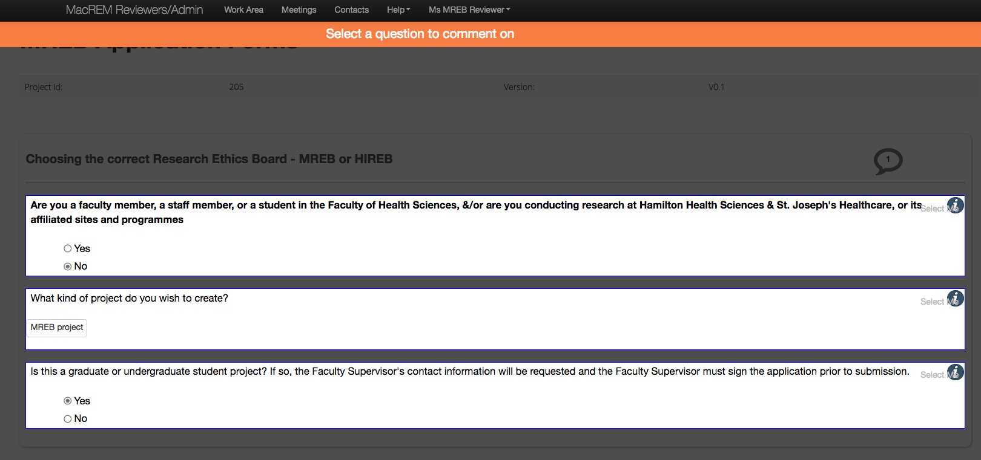

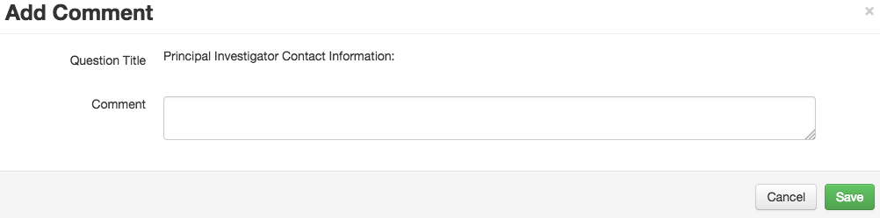

4.4.2 Form Comments

To make a comment about the whole application in general, click ‘Form Comments’ on the action toolbar.

This will bring up a pop-up window. Click ‘Add Comment,’ enter your comment and click ‘Save’.
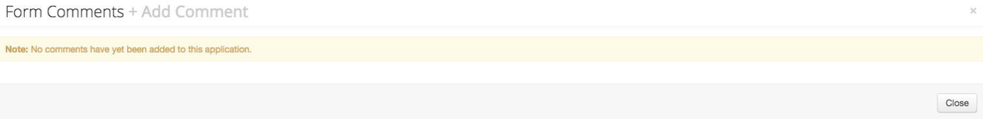

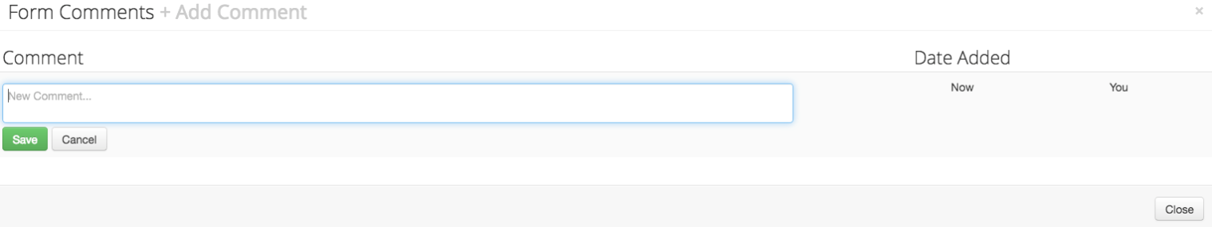

4.4.3 Editing Comments

You can edit both Form Comments and Panel Comments. To edit a comment, find the comment (by clicking on the ‘Panel Comments’ or ‘Form Comments’ tiles).

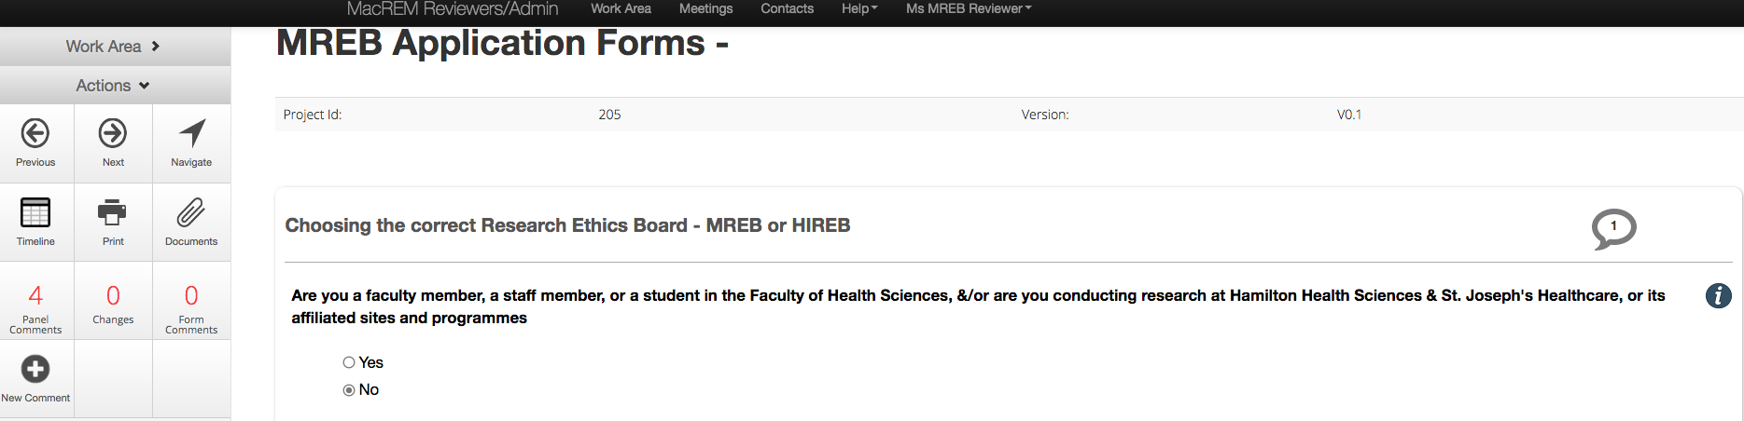

Use your mouse, highlight the comment you wish to change, and click ‘Edit’.
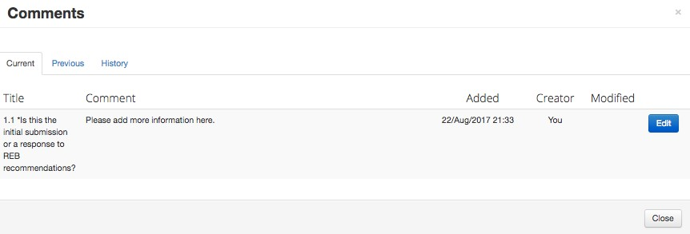

This will give you the ability to edit the comment. Once you are satisfied with changes you have made, press the ‘Save’ button.

If you wish to delete the comment altogether, press the ‘Delete’ button.

*NOTE: Only the person who created the comment can delete the comment. The Chairs will be able to edit your comments and make them directly visible (or not) to the applicant, as well as to ask for changes.

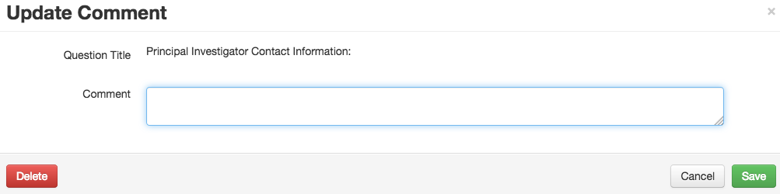

4.4.4 Reviewing Comments Made by Others

To review a list of comments made by other reviewers, click ‘Panel Comments’ or ‘Form Comments’ from the Actions Toolbar.
The number on the tile indicates how many comments have been made.

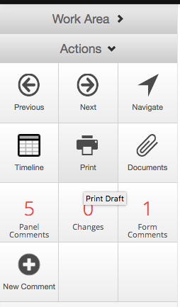

4.4.5 The Letter from the Chair to Researchers

After the Chair has contacted the researchers with the review outcome, you don’t have to be copied on the email to researchers. You can find the letter in the Notifications area called “Changes Requested”. This is the simplest way for the time being to see how your own review comments were conveyed to the researchers. Also, you will be able to access the application again in the “My MREB Cleared” tile to see how applications were reviewed.

4.4.6 Submitting a Review

Now that you have added and reviewed your comments it is time to submit your review. The faster short cut to find the action button to submit the review is to click the Timeline button. The next way to is to click either the Home button or Work Area in the top menu.

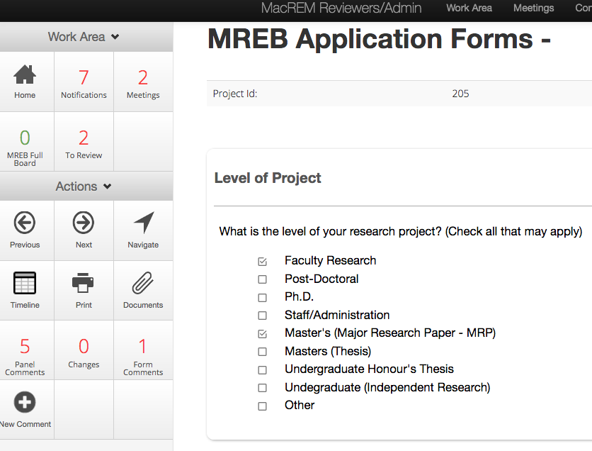

Find the protocol you were reviewing in the My Reviews tile and click on it. Now you will be able to see the Submit MREB Review button. You can also return that page by clicking the Timeline button when you are in review an application mode.

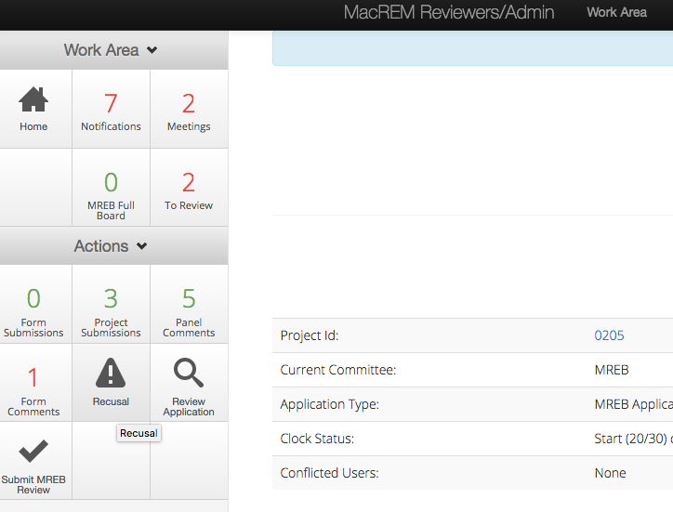

When you click Submit MREB Review you will see the following screen. In almost every case you just need to click the green Submit MREB Review and your review will go through. You will not receive an email confirmation.

4.4.7 After a Review is Submitted

After your review is submitted, the review will remain in the same To Review tile. You should receive an email acknowledgment copied to the MREB Administrators that your review has been submitted. You will only get a few applications to review each month so it should not be too difficult to remember what you have reviewed and submitted. Once the other reviewer has submitted their review, the protocol will be assigned to the Chair, and it will automatically be removed from your To Review tile.

There are however 3 other ways to verify that you have submitted a review. The first is that when you submit a review, your Notifications tile count will increment by one with a system notification that your review has been submitted, as in the illustration below:

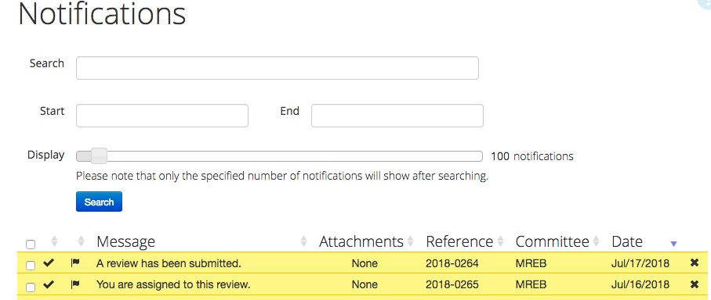

The next way is to take notice of the Timeline Notification Message column when you click on the protocol to open it for review. If you see a line that says “A review has been submitted” before you submit a review, you know that the other reviewer has submitted a review. That will also be obvious because you will see their panel comments. If you don’t see that before you do a review, but you see it after the review, then you have submitted a review.

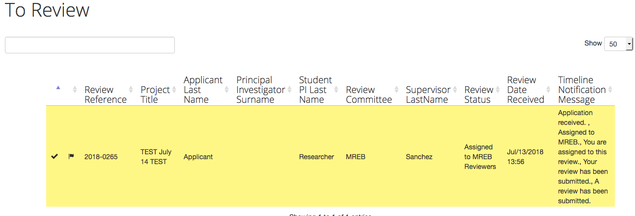
Click checkmark

The final way is to manually remove the count on the application so it doesn’t increment in your To Review tile. To do that, check the black check mark on a yellow highlighted screen of the protocol (as in above illustration). That will turn the check mark colour to green, and the yellow highlighting to white. As well, if your To Review tile indicated that you had 1 application to review, it will now indicate 0. It doesn’t remove the protocol from your list, it only removes the count.

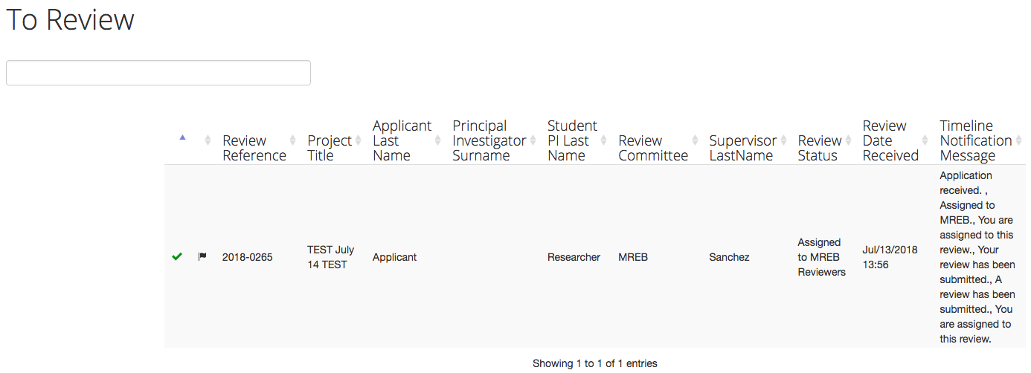
Green checkmark

Many reviewers are curious about how their reviews were used by the Chair in conveyance to researchers. When a Chair sends a revision letter to the researcher, you will receive a system notification and be blind copied on an email that you can access in the Notification tile called “Changes Requested”. It will indicate a paper clip which is a PDF letter of the review. When you click on it, it will open the PDF– as illustrated below:
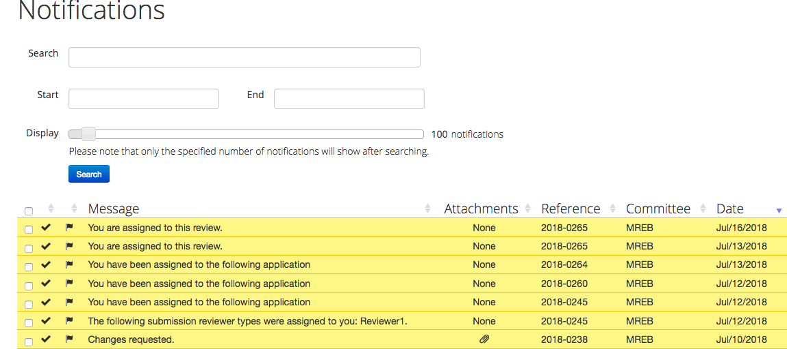

Once the Chair has cleared the application that you reviewed, it will move to the ‘My Cleared Reviews’ tile if you want to review the application again to see the final panel comments that were made on it.

4.4.8 Writing Panel Comments Best Practices

The MREB Chairs highly recommend writing panel comments as if you were directly addressing the researchers, or how your comments would directly appear on the application. Please identify the specific issue or content with which there is a concern and explain why it is a concern. Avoid use of “personalized” comments such as “I recommend” or “To me this implies” (unless the comment is directed to the Chair, e.g. “I think this data may actually be identifiable, but I’m not positive, so flagging it for the Chair to confirm”).

Additionally, it is helpful for the Chair if you specify if the comment is a “major concern” - a critical ethical issue that negatively impacts participants and needs to be addressed for the study to proceed. Likewise, specifying if the comment is a “collegial comment” lets the Chair know that it is something that could improve the study, but is not an issue that has to be addressed by the researcher for ethics clearance. All other comments will be assumed to be in the “minor concern” category, so it is not necessary to preface minor concerns.

Starting the comment with “major concern” or “collegial comment” will flag it for the Chair, and often could be left in when the comment is sent to the researchers. For example;

“Major Concern: The researchers propose to withhold the bonus marks from students if they withdraw. This is contrary to the TCPS interpretation on incentives for students.”

“Collegial Comment: Consider adding standardized questionnaire X, as it is commonly used in this area of investigation and has been validated.”

4.4.9 Conflict of Interest

There is no Recusal or Conflict of Interest button and you should contact the ethics office if you think that you need to remove yourself from this review. The ethics office will discuss with you whether or not you have a “manageable” conflict of interest or if you should just not do the review.

4.4.10 Confidential Review Comments

In the MacREM system reviewers know which other reviewers are assigned to the protocol and know who made which panel and form comments during the initial review process. In this way it is like being at an REB meeting and sharing comments on the ethics application.

However, there may be a rare case when you want to make a comment or raise a concern and do not want other reviewers to see that it came from you. If that happens, please send your comment via email to ethicsoffice@mcmaster.ca and when the Chair is assigned to the application the ethics staff will send your comment directly to the Chair to consider. If the comment is included in the feedback, then it will be entered into MacREM by the Chair.

5. Additional Information

The FAQ link from the MacREM Help menu will be populated with MacREM reviewer related guides and answers to questions. Reviewers may make an appointment anytime with the ethics staff for training on MacREM. If you have any ideas on how the review system can be improved or a critique on the usability of the system, please let the ethics office know.

