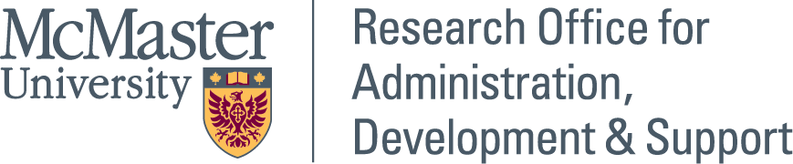

MCMASTER COVID-19 RESEARCH FUND
NOTICE OF INTENT (NOI) FORM

If you intend to apply to the McMaster COVID-19 Research Fund, it is required that you complete this form and send it to your Associate Dean, Research, and copy Christina Pellegrini, Senior Advisor, Development, ROADS, at pellegrc@mcmaster.ca, by May 4, 2020.

- Anticipated Investigator/Team
 | Name  (first and last) | Department & Faculty/  Institution (if not McMaster)*
Principal Investigator:

Co-Investigators:
(if applicable)

*Please note, the McMaster COVID-19 Research Fund supports research projects led by McMaster researchers. Members of the research team from outside of McMaster are expected to be self-funded.

- Anticipated Partners (if applicable)
Partner name | Anticipated contribution ($)  (specify cash or in-kind) | Secured or Potential

- Application Stream (please select one):

☐ Stream 1: will support research with immediate and short-term outcomes, with a focus on real-time impact during the current COVID-19 crisis.

☐ Stream 2: will support research aimed at longer-term outcomes, with a focus on impact on recovery from the current crisis and/or preparedness for future pandemics.

COVID-19 Research Funding request: | Additional Funding:  (If applicable, please identify whether this project is supported by funding from other sources. Indicate whether funding for this research has been requested from another source where the result is pending.)
$ | $

- Summary of Proposed Research Program (100 words):

