McMasterREM (MacREM)

MREB Chair Procedures

User Guide

Helpdesk: 905-525-9140 ext. 23142
Email: macrem@mcmaster.ca

Table of Contents
1. Login to MacREM 2
2. Work Area and Tiles for the Chair 3
2.1 General Tiles 4
2.2 Reports 5
3. My Chair Reviews Tiles 5
4. Application Tiles 6
5. MREB Tiles 6
6. Reviewing an Application 7
6.1 Review Application 8
6.2 Request Revision Letter 11
6.3 MREB Email Clearance and Amendment Email Clearance 15
7. Responding to Researchers 17
7.2 Question 1.4 Response to REB Recommendations 19
7.3 Alternative Approaches to Corresponding with Researchers 19
7.4 Send Local Review Notice 19
7.5 Executive Clearance Letter 20
7.6 Not Approved 20
7.7 Invite to Full Board 20
7.8 Clear Amendment Email 21
7.9 Reports and FAQs 22
8. Project Tree, Timelines and Document 22

1. Login to MacREM

MREB Chairs login to MacREM through the same portal as the MREB reviewers, the Ethics Officers, and system administrators. The access to files and procedures for Chairs is customized for the tasks they need to accomplish. Access is by MacID email followed by MacID password. Here is the login page:
https://macremreview.mcmaster.ca

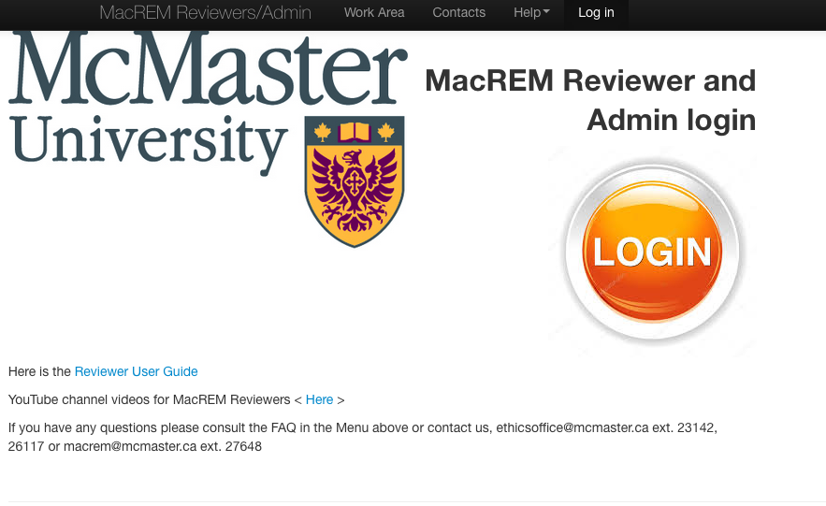

2. Work Area and Tiles for the Chair

The Work Area can also be accessed through the top Menu at any time when navigating through a protocol. The following information will help define what each of the tiles in the work area is and how it is used. Each of the squares on the work area is called a “tile” but it is ok to think of it as folder with a list of protocols, messages, tasks, or other information. The tiles are organized into Tile Groups and for the unique Chair’s view there are currently General, My Chair Reviews, Application and MREB.

Tiles are shared through permission settings owned by the System Administrator. The System Administrator can move tiles around into different groups and can customized how the content of each is organized and presented. New customized tiles can be created at any time. Tiles can be shared with Reviewers and Admin, but not applicants.

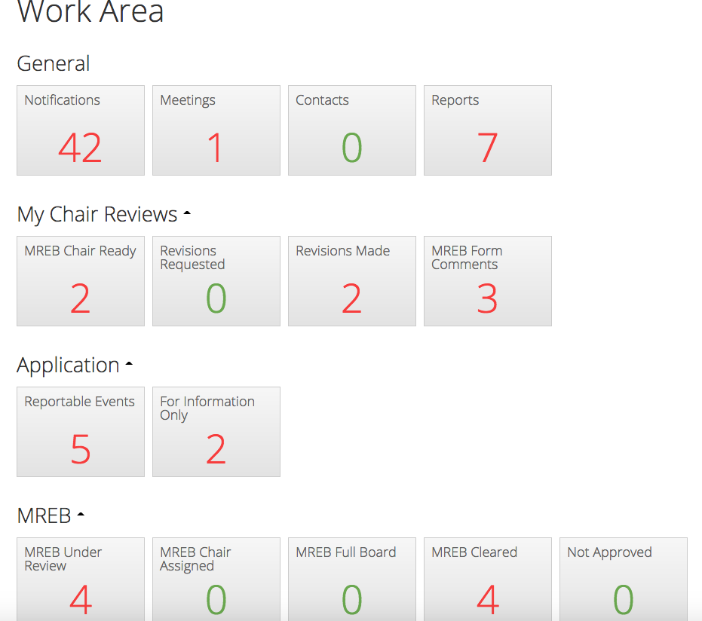

2.1 General Tiles

The kinds of tiles currently in this configuration can be changed and altered depending on the requirements of the Chairs and Admin staff. The General area however is more of a default system design area, common to many users, for their specific roles.

- Notifications – Notifications are messages and file attachments sent through the system. They are sometimes only sent through the system but at other times they are coupled with an email that may have attachments. Some examples of notifications are:
- Changes requested (with attachment) - a system notice and email sent to researchers asking for changes. The attachment is the PDF letter you sent to researchers with the review outcome comments.
- This application is ready for you to clear – a notification and email when both reviews have been returned – prompted by the Ethics Officer
- You have been assigned to the following application – a notification only that you were assigned a protocol to act as Chair but reviews are not back yet
- The MREB researchers have made changes. Could be ready to clear now – the researcher has made changes but it is up to you to decide if it is ready to clear or if you have more comments or concerns. You will find the protocol in the Revisions Made tile.
- Correspondence Received – there is a Correspondence tab on the Project Timeline and occasionally an applicant might use this to send correspondence. This feature will not be encouraged but it will be there and will be useful in some cases.
- Meetings – When there are MREB meetings there will be information on the meeting
times, who will be at meeting, where the meeting will be, as well as the agenda and agenda material.
- Contacts – A list of contacts, such as MREB reviewers can be generated here. This list
is separate from any contact list you might make as an applicant or
researcher.
- Reports – Reports are created by the Sys Admin or Ethics Office. They can be monthly,
yearly, daily, or of any sort relevant to your work. Reports are generated using
filters on fields, in submitted protocols as well as system times, clocks, and
processes. Every question in all the forms has a field name where reports can pull data from.

2.2 Reports

- Ready for Chair – A report that just indicates which protocols are ready for the individual Chair. There are now personalized tiles that do the same thing.
- Contact for Local Reviewers – This report queries data on application forms to pull in the contact information (email and name) for local reviewers for international researcher. This is easier to access then navigating through an application.
- More than Minimal Risk on Application Form – This report also brings in data from application forms on this question of risks greater than everyday life.
- Last Meeting Report – This report will also be found in the Meetings tile. It has a list of the all protocols cleared since the last meeting with a hypertext link to the actual protocol.
- Reports can be generated as per request anytime. All questions in the application forms are potential form data that can be used to query and generate reports.

3. My Chair Reviews Tiles

This specific group of tiles is individualized for each MREB Chair. You will only see the applications that are ready for you to clear in these lists.

3.1 MREB Chair Ready

When two MREB reviews are returned, the Ethics Officer will send an email and a notification through the system, like this sample:
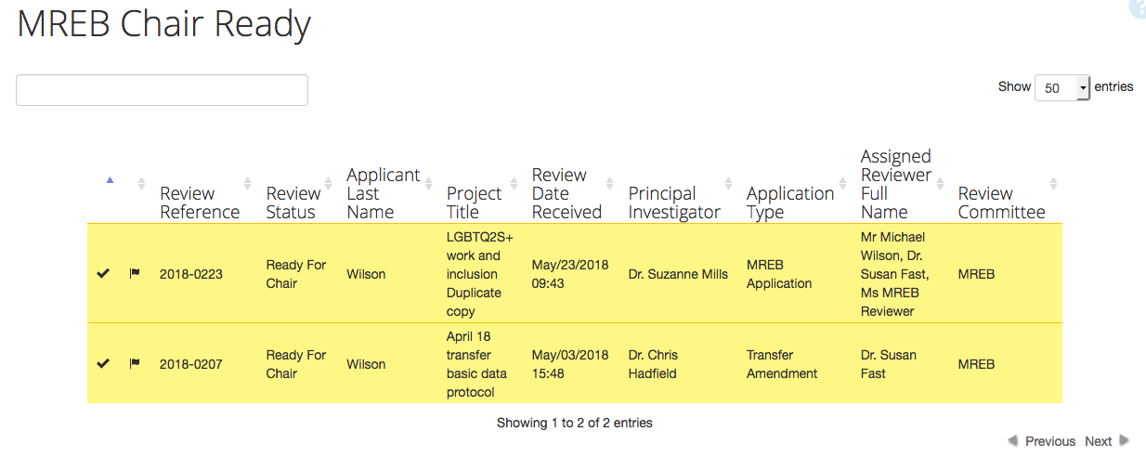
The MREB reviewers have completed their review and this protocol is now in your Ready to Clear list.
Review Chair: Ms. Test Chair
Date Submitted: Jun/07/2018
MacREM Project Number: 2018-0194
Principal Investigator: Mr. Joe Applicant
Student Investigator: Barry Goldman
Project Title: expiry dates april 11
You may login to MacREM and view the application here:
https://mcmaster.review.ethicalreviewmanager.com/Timeline/Index/308

If you click on the hypertext link you would land directly on the protocol for review, were you already to have been logged in. The protocols for your review will increment in this list. If there are 4 ready for you to clear and another one becomes ready it will increment to 5 in this tile. Click on the tile to see the list of protocols then click on the protocol you want to review. Thelist of protocols will indicate the Date received, PI, Review Reference#, title, reviewers, Assigned Chair, and Type of application (amendment, standard application). This list of columns or fields can be customized by the Sys Admin or Ethics Officer. The Review Reference# is what will replace what used to be called the MREB protocol number. It is assigned automatically by the system and the order of sequence will not be uniform. The Project ID number is actually generated each an applicant creates an application, and not just upon submission.

3.2 Revisions Requested
After you send your comment letter to applicants the protocol will automatically move or increment into this tile. There is no need for further action and this placeholder is meant to help track the application through the review process.

3.3 Revisions Made
As it sounds, when researchers have made changes and sent them back through the system, they will increment into this tile. You will also be notified by email and system notifications when the revisions have been made. It is time for you to respond to the revisions. If the response is not adequate and you cannot clear the application, you will send it back to the researchers, so the protocol will increment into the Revisions Requested tile again.

3.4 MREB Form Comments – This tile presents a way for you to see at a ready glance the Form Comments reviewers have made on applications under your purview for clearance.

4. Application Tiles

In the Ethics Officer access view under Application there are tiles for All Applications, Cleared Conditional Release, MREB Transfer, Reportable Events, and For Information Only. The Reportable Events tile and the For Information Only are the only ones currently shared with the Chairs.

4.1 Reportable Events – The Chairs will need to be informed about Reportable Events such as Adverse Events, Privacy Breach, Protocols Deviation and Study Complaints. Sometimes events such as reports For Information Only, or minor administrative changes, do not need to come to the attention of the Chair. Actual details of these reports may also be created as Reports through filters on actual form fields.

5. MREB Tiles

This series of tiles tracks applications through and beyond the review process, from the point of view of relevance to the work of the Chair. Here are the current tiles and how they function. These are subject to change and redesign:

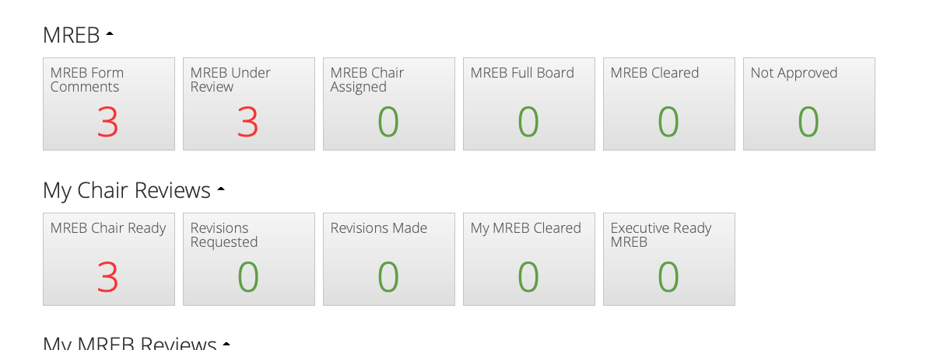

5.1 MREB Under Review – This is the current master list of all applications that have been assigned to MREB chairs for review – not the individual list you as Chair have been assigned. At this stage the protocol has not even been assigned to you. You will be able to see who the reviewers are, and you can read these protocols at any time if you wish.

5. 2 MREB Chair Assigned – When the Ethics Officer assigns a protocol for your review, it will appear in this list, as well as the protocols assigned to the other MREB Chair(s). There is no action you need to take on this until they are made ready for you to clear. You may still access and read these protocols but you should not do an active review until they increment into the MREB Chair Ready tile.

5.3 MREB Full Board – This tile indicates when a protocol has been assigned to a meeting. The protocol will also be available for view in the Meeting tile. It does not necessarily mean that the protocol is greater than minimal risk requiring full board review.

5.4 MREB Cleared – After you have cleared an application by sending the clearance email it will increment into this Tile. They will decrement when the Ethics Officer sets an expiry date for annual reports and sends them the official clearance certificate.

5.5 Not Approved – As it sounds, if you push the button not approving an application it will increment in this tile until further action of some sort is taken, e.g. withdrawal, resubmission, etc.

5.6 Executive Ready MREB – The Ethics Officer will send a protocol to this tile when it is an executive clearance type of application like amendments, or applications cleared at other universities.

6. Reviewing an Application

When an application is ready for your review, you go to the MREB Chair Ready tile and click on the application that is ready. You will see a screen like this:

Clicking on Review Reference 2018-0223, you will see this screen:

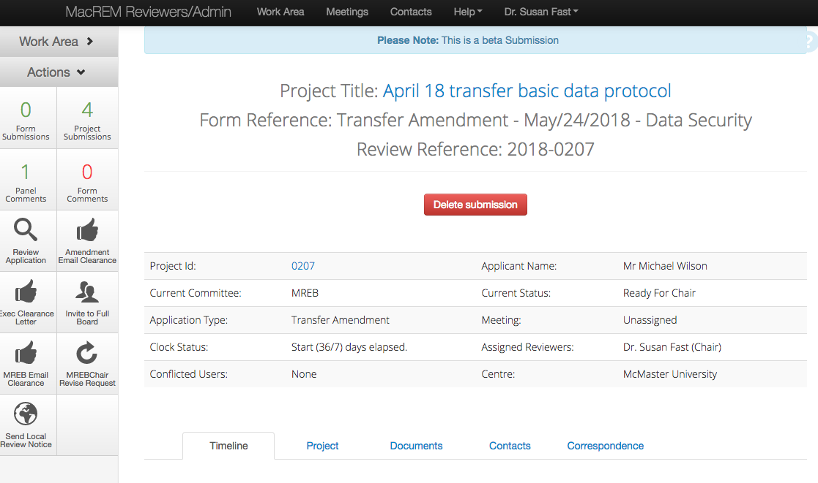

The arrow is pointing to the Actions panel. This is where you need to return in order to read or Review the Application, send an email of clearance to the researchers, or request changes. Those are all Actions. You can also notice the number of panel comments (1) that reviewers have made on the application, and the number of Form comments (0). Form numbers only increment once for each reviewer but there can be as many panel comments as there are questions on the application form. There is a maximum of 2 form comments – one for each reviewer. Form comments are overall impressions or comments not specific to panel or question(s) on the application form.

6.1 Review Application

When you click the magnifying glass Review Application you are taken to the application to review. In the Action Panel you will be able to access the list of Documents associated with the application and even read Panel Comments and Form Comments before even reading the application section by section. It is probably advisable to read the application section by section taking note of the Panel Comments from the reviewers as you go along:

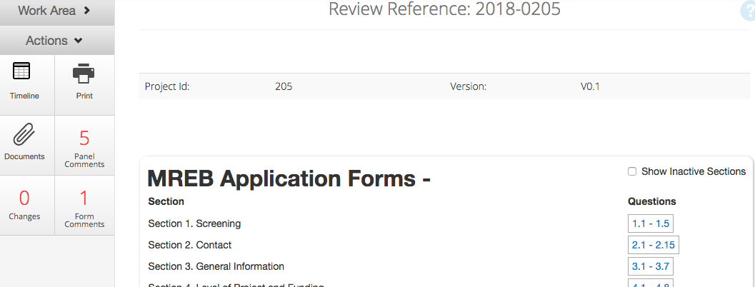
Timeline

Please note that after when you are in this view and you have read the application and navigated back to it, by clicking the Timeline tile (above image) you will return to the page that has the Action buttons for all the letters and emails that are sent to the researchers.

When you click on some questions to review, if there are panel comments they will appear not only in the left navigation, which is in incremental number total of panel comments, but also in a grey bubble to the right of the panel where the comments were made. Clicking the number in the bubble will display the comment:

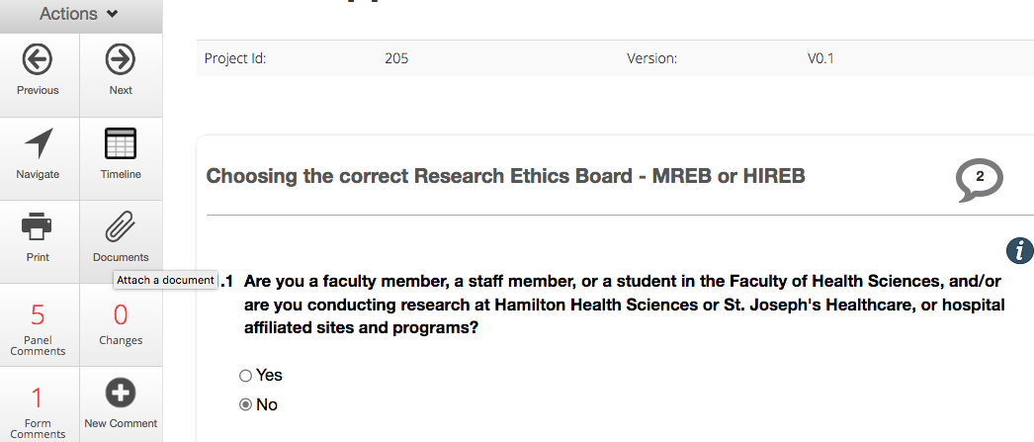
Click bubble to view

The task of the Chair at this point is to accept or edit the comments from reviewers and make them visible to applicants. You have to click the greyed out “Applicant” and “All comments to be made visible to the applicant” button in order to make it green with a check mark. These comments that the Chair edits and makes visible will also appear in the Chair’s letter as a record of the review when sent to the researchers. This is the automated way of doing the review.

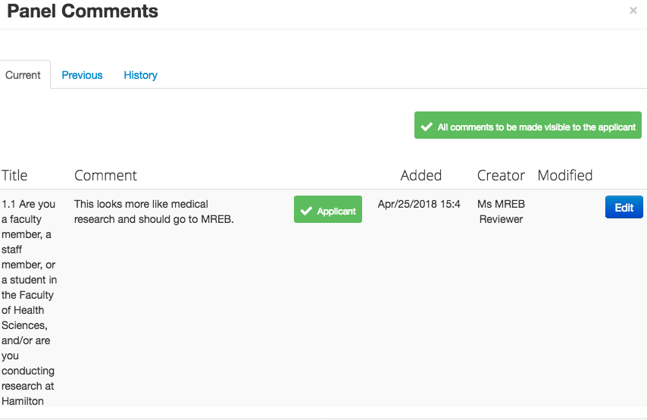
Click to make green

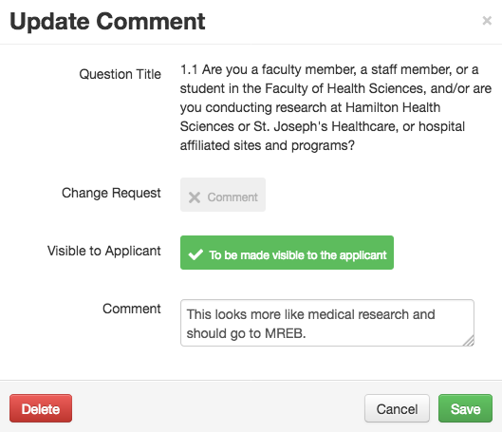
Click to make green

Clicking the greyed-out Comment button to make it green is a Change Request feature. This will make it more certain that the applicant needs to respond to this comment. Panel Comments can’t be deleted, even though a delete button will appear. Only the reviewers can delete their own comments.

You don’t have to review the application online. You can click the Print button on the action panel and make a PDF copy (with or without the review panel comments) to save to your computer to review later. It loads very slowly into a PDF and includes all the attachments at the end of the form.

If there are more than several comments on the panel for the letter of information you could copy and paste all the comments into one panel to keep them together.

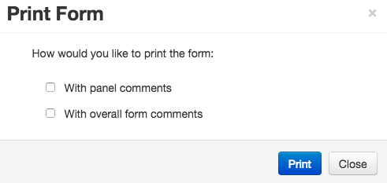

6.2 Request Revision Letter

Once all the panel comments have been edited, and the Chair has added their own comments, it is time to prepare the letter that will be sent to the researchers asking for revisions. Click the Request Revision Letter button. If you have an alternative name, and it is within the character count, we can rename any action buttons or tiles.

After clicking this button the letter to researchers will open in a smallish HTML editor window. It will import the all anonymous panel comments into a table, as illustrated in this image:

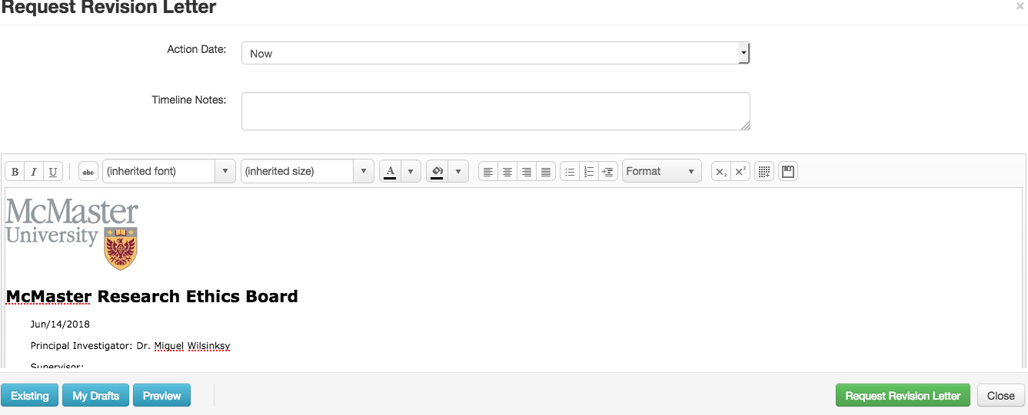
Save Icon

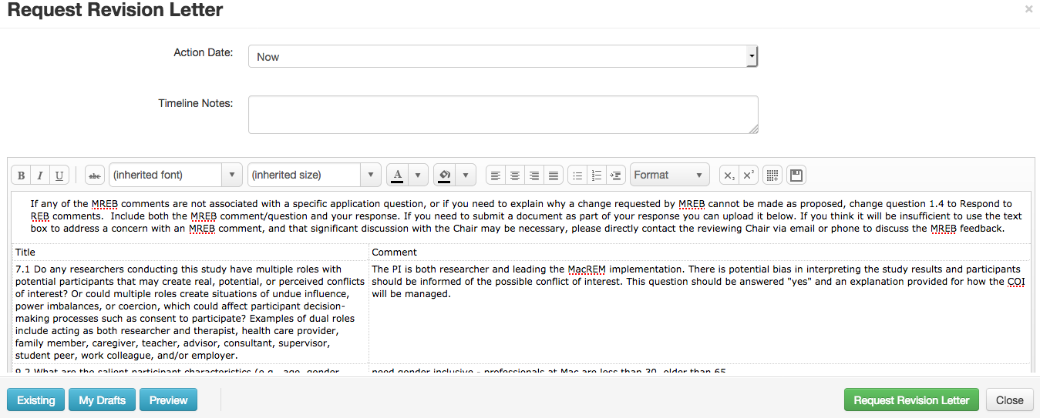
Anonymous panel comment

At this point, if you have previously edited all the comments, you should just be able to click the green Request Revision Letter button. The system will prompt you if you want to send one more time. When you do send it, it sends an email notice to the researchers to login and see the response. The letter is made into a PDF. You the Chair will also get a copy of the letter which you can find in the History tab and the notification area.

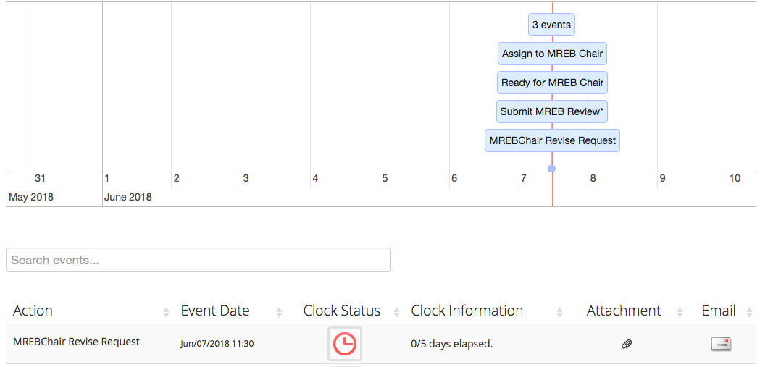

This letter is a record of the review outcome.

If this was a straight clearance, you could probably either just avoid the letter or write in the letter that you are cleared - Nice work! Next, you would still have to click the action button called MREB Email Clearance to send a template email of the clearance, also for the record.

In many cases, though, you will have to edit this letter and save it as a draft. The automated way to do this is using the online tools as presented, and the less automated way is to draft a letter on a local computer in Word and then paste it back in. As soon as you click the green Revision Reguest Letter button, it will save whatever is on the letter. If you want to draft a letter using the online edit tools you can click the Save Icon. This will open the drafts folder where you can name the draft of the review.

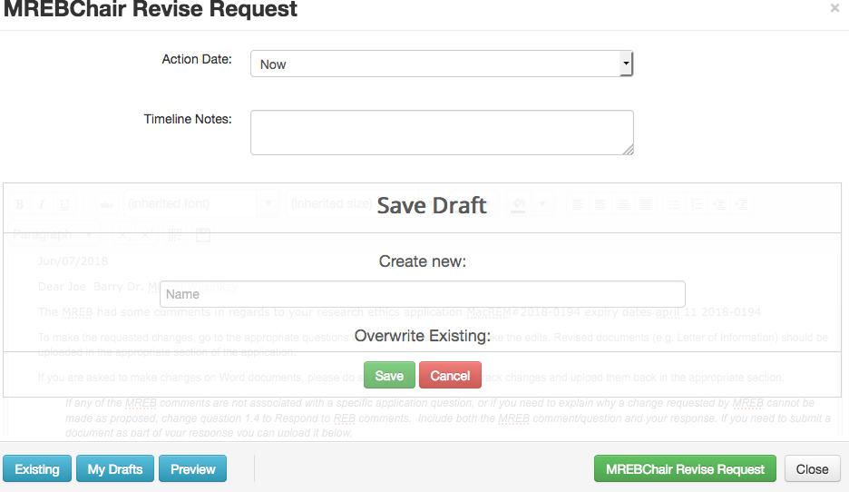
Overwrite

When next you login to continue the review you would go to the blue My Drafts button to find the draft. To bring the saved draft into the screen you would have to “Overwrite the existing” letter which has been output from the reviewer system again, as if you had never edited it.

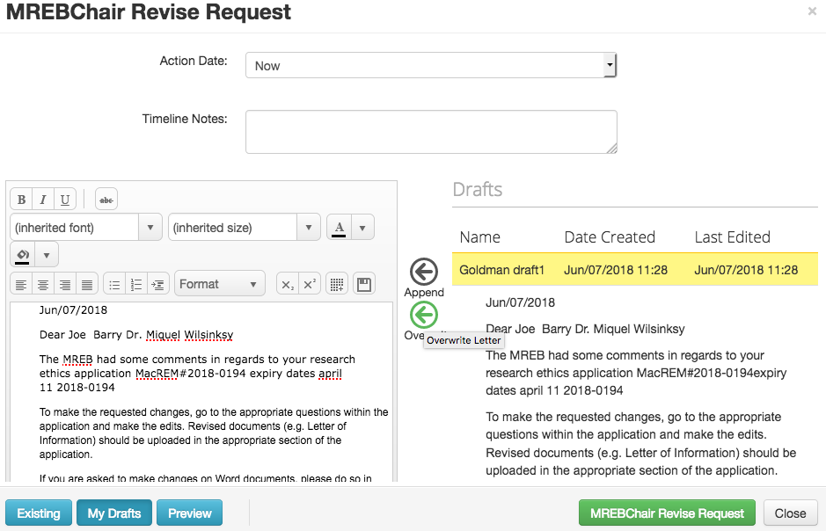
Overwrite

There is template instructional language in this template letter and currently it reads as follows:

Steps to Respond to MREB Comments

1) Go to question 1.1 in the amendment application and select “Response to REB Comments”.

2) Revise the MREB Form

- Refer to reviewer comments in the attached PDF letter.
- Navigate to applicable questions within the online form and make the revisions.
- Edits to the application form should be made within the online interface so the system can track the changes (as opposed to making changes in a Word document and then pasting back into a text field in the application).

3) Revise Supporting Documents if Required (e.g. Letter of Information, Questionnaire, etc.)

- Use grey highlighting or track changes so the Chair can easily see revisions.
- Upload a PDF version of the revised document(s), with a new version number, to the appropriate question within the application.
- Delete the old version of the document(s) from the application.

4) Summarize the Revisions for the Chair

- Create a document that lists each reviewer comment (and question number), along with your response to the comment. You may want to copy the questions and comments from the Chair's PDF letter.
- In many cases the response may simply refer to changes made within the online application, (e.g. "Revised the consent process, see changes in 6.2").
- Use italics, or some other visible formatting, to distinguish your response from the reviewer comments.
- Any changes you make to the application that are in addition to responding to reviewer comments should be explained in the document as well.
- Refer to the Sample Summary of Revisions document if needed (See Help/Templates in the top menu of MacREM, or click < here >).
- Upload the summary of revisions document to question 1.3 on the amendment form.

***Once everything is done you can sign the form to resubmit to the Chair***

Following the above steps will make it easier, and therefore faster, for the Chair to review the revisions.

If you think it will be insufficient to use the summary document to address a concern you have with a specific reviewer comment, and that a discussion with the Chair may be necessary, please directly contact the reviewing Chair via email or phone.

When drafting your letter to the researchers, if you cannot settle your concerns through the panel comments, you can specifically ask the researcher for a more substantial response, by slightly editing this instructional wording.

After you send your review letter to the researchers, it will increment in the Work Area tile called Revisions Requested. The means it is in the researchers’ court now.

The email that is sent with the Revision Request letter is like this:

Today's Date

Dear Applicant Full NamePrincipal Investigator Full NameStudent Investigators Full NameInstructor Full NameSupervisor Full Name

The McMaster Research Ethics Board some comments on your application. Please login to MacREM to respond to MREB comments and make revisions. Please also see the attached PDF with the comments (which is can also be found in the Notifications area of MacREM).

Date Submitted: Today's Date

MacREM Project Number: Review Reference

Principle Investigator: Principal Investigator First Name Instructor Full Name Principal Investigator Email

Student Investigator: Student Investigators Full Name Student details Email

Student's Supervisor: Supervisor First Name

You may login to MacREM and view the application comments and notifications from the Ethics Office here:

Links Project Direct Link

Regards

Chair Full Name Chair Email

6.3 MREB Email Clearance and Amendment Email Clearance

When the researcher sends back the response, the protocol will increment into the tile called Revisions Made. You will receive an email and notification that is ready for you to clear.

When the researcher responds by resubmitting the application, you will be able to review Track Changes of the edits they made. Green highlights will be new wording added to the application and red strike throughs will be deletes. You can instantly go the Changes tile in the Actions panel to go through the changes the researcher made. If you asked for a substantial change requiring them to answer question 1.4 this will be indicated as a Change. You can also access their uploaded document(s) in the Documents button.

At this point making panel comments and sending another letter is possible, but the original panel comments will only appear in the Previous tab of the panel comment, and not the active.
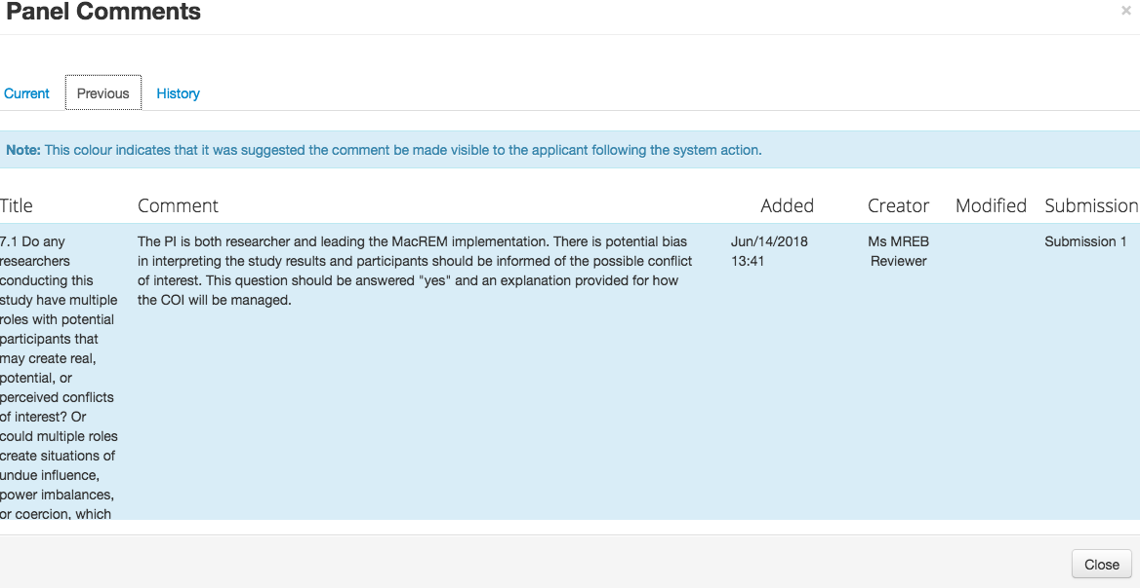
Previous panel comments

An additional letter and round of correspond could go into the loop again. If all is well, all you need do is send the email of clearance by returning to the area that has the action panel and clicking on the MREB Email Clearance action button. Clicking the button will also bring up a standard letter in case there are additional comments you need to make. For example, you might have a collegial comments or there might be a requirement that the researchers submit a clearance certificate from another university once that is obtained - can mention that in this letter. Otherwise, you can just send the letter and the email at the same time without editing the letter. This is a template email indicating they are officially cleared and that the Ethics Office will soon send them the official letter of clearance. The Ethics Office is also going to set an expiry date for annual reports, which will appear on the letter. This is the wording on the email clearance template:

Today's Date

Dear Instructor Full Name Student Investigators Full Name Supervisor Full Name Principal Investigator Email Co-Investigator Email Co-Instructor Email

You have research ethics clearance for this amendment for Review Reference. Please note that there might be more information about this clearance in the attached PDF letter. You will soon receive your clearance letter from the ethics office.

Principal Investigator: Principal Investigator Full Name

Instructor: Instructor First Name

Supervisor: Supervisor First Name

Student Investigator: Student Investigators Full Name

Good luck with your research!

Chair Full Name Chair Email Committee Name

Links Project Direct Link

The Amendment Clearance Email action button does the same thing but the template wording refers to an amendment. There is currently no numbering system for the number of amendments, like Amendment1, Amendment2 etc. If there are comments and concerns to be made on the amendment, the Amendment Clearance Email Letter button should be used again.

7. Responding to Researchers

7.1 Track Changes

When the researcher logins they will be able to see at a glance how many panel comments have been made on the application. When a researcher deletes or edits the text in a question based on a panel comment, the changes made will appear in red and green colour highlighting if the Chair clicks the blue <View Changes> button on the question where the changes were made. Deletes will appear in red text strike through, in the text field and if the researcher adds new text, it will appear in green text. This makes it easy for the Chair to see the changes. The track change feature only works on the “resubmission” status. Previous changes and comments and the history of panel comments can be found in the tabs of the panel window. If the researcher made some new changes it will increment in the Changes tile. In the sample below the applicant made 8 changes. If you click that icon who will be given a list of the changes. You can click each link to drill down into the change on the application.

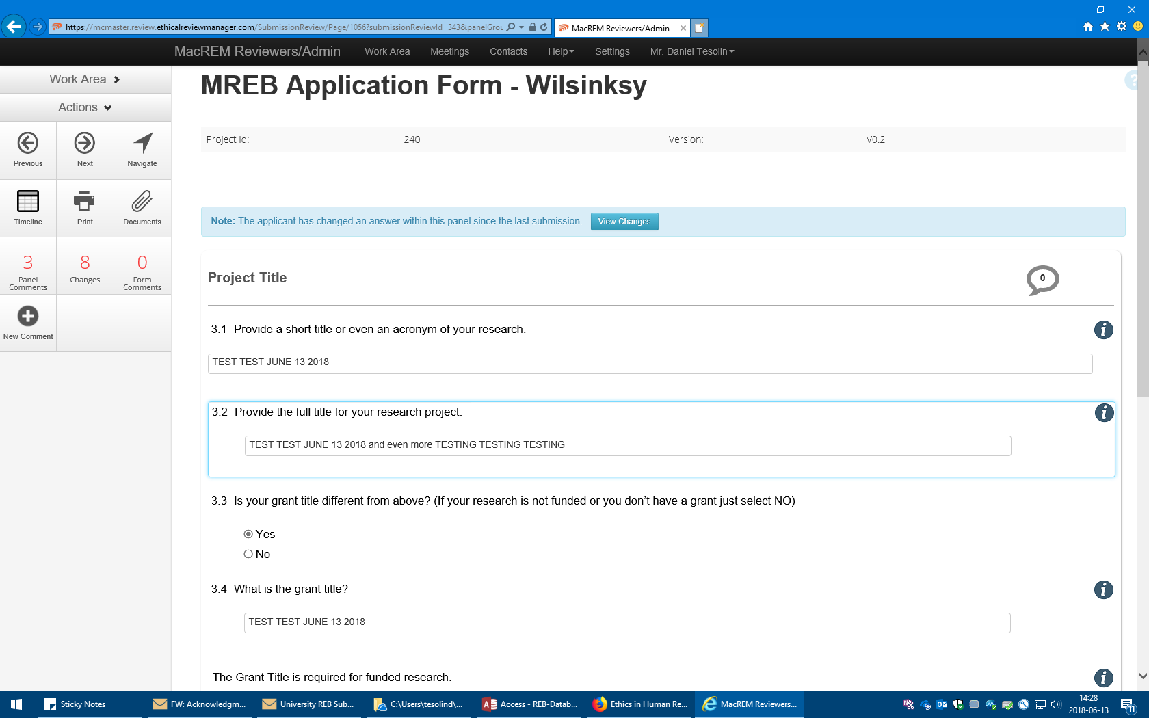
View Changes

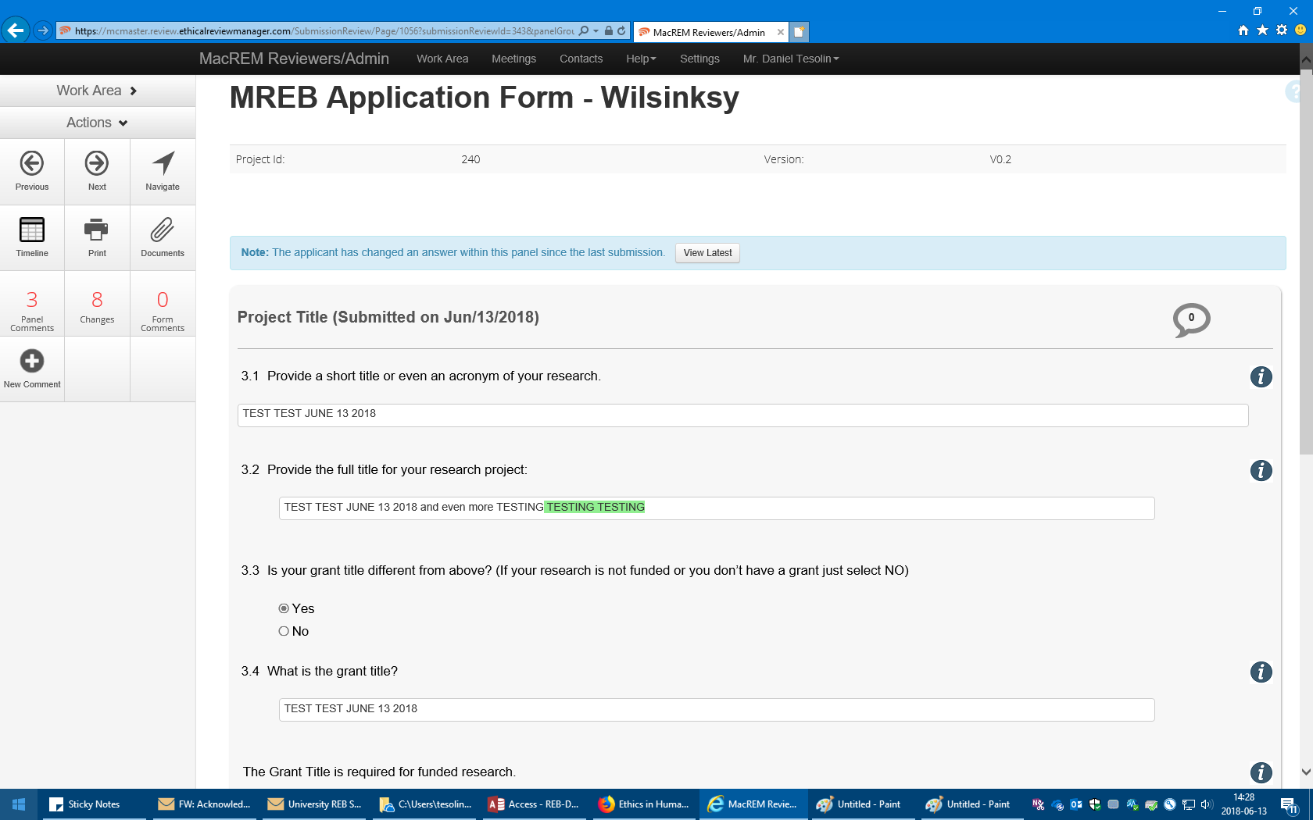
New Changes
New Text

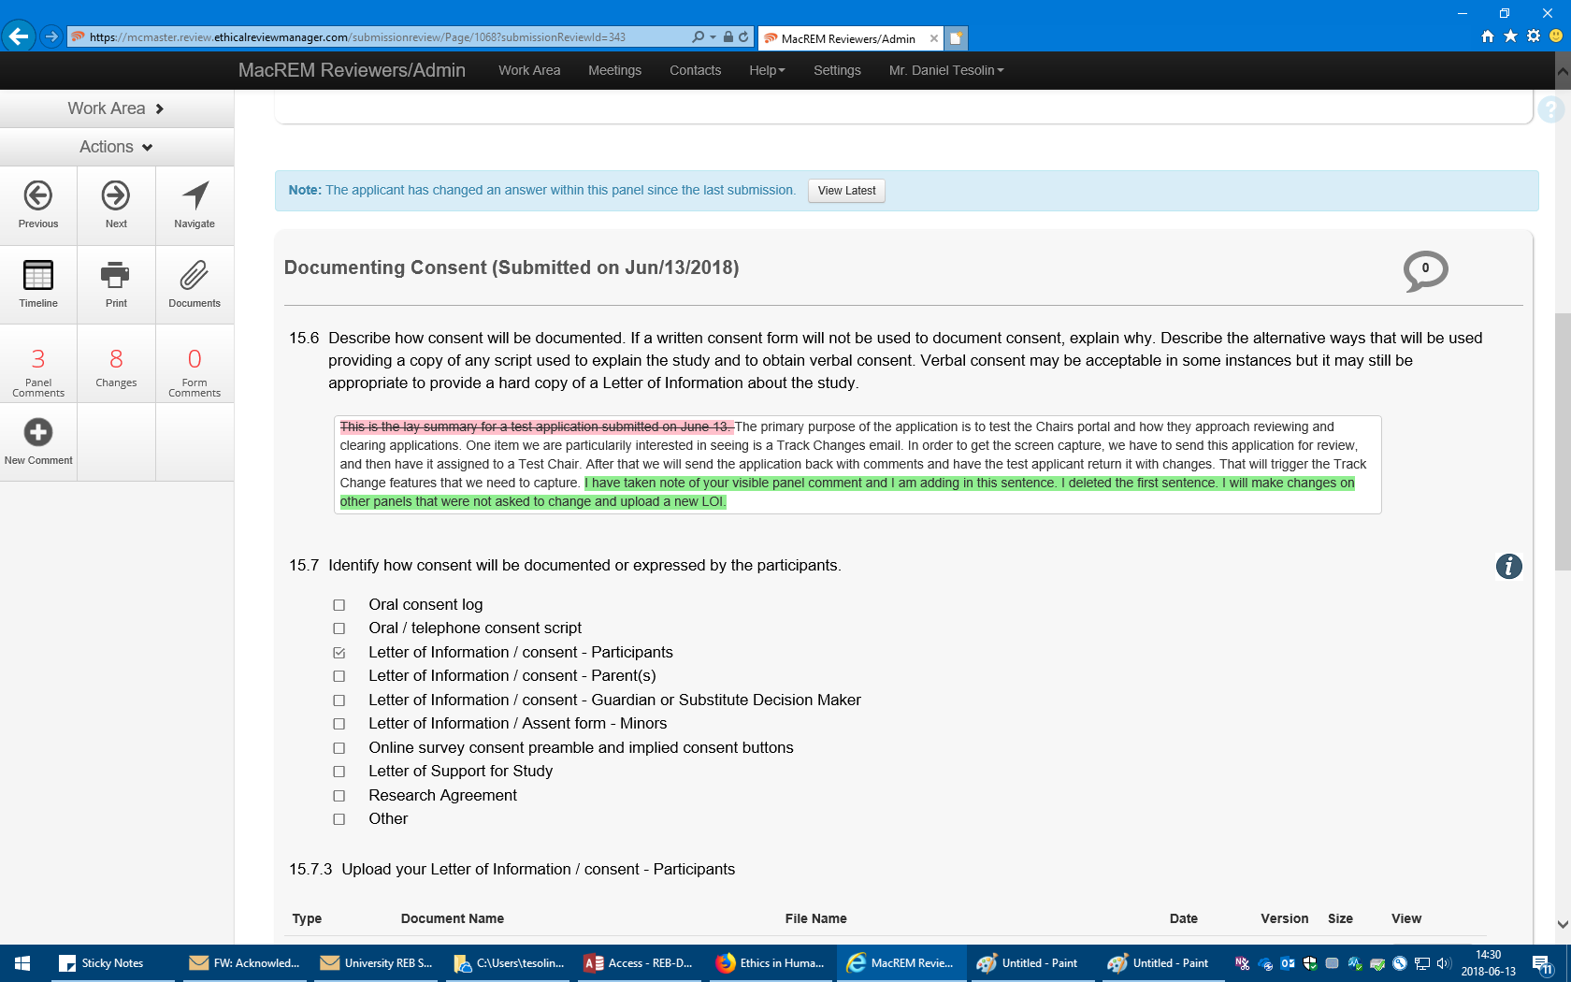
Deleted Text

7.2 Question 1.4 Response to REB Recommendations

This is a mandatory field for all researchers to respond to the Chair’s comments by creating a summary document of the comments indicating how they respond to each, and what updates they made to the application form.

7.3 Alternative Approaches to Corresponding with Researchers

Alternative approaches to corresponding with researchers are the telephone and face to face meetings. Documents from such meetings can be uploaded to the Review Document area of the application for the record but won’t be shared with the applicants. The Review Document area is only seen by the Ethics Office, the Chairs and Reviewers. You can find the Review Document by clicking on an application to see the Timeline and clicking on the Document tab:

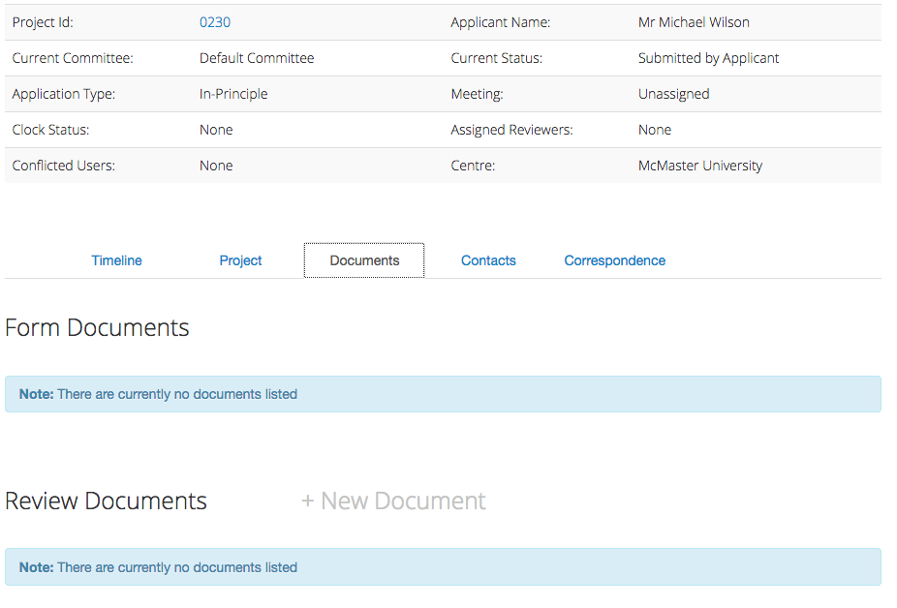

Another approach is to copy the panel recommendations into a Word document and working offline with it before uploading it back into the edit window to save as a draft. It is important to remember to overwrite any drafts so only the edited version is sent to the researchers.

We will continue to look for ways to improve this process.

7.4 Send Local Review Notice

Clicking this button will send a template email informing researchers who are doing research in a foreign country that the local reviewers that they listed on the application form are being contacted.

Here is the email template:

Dear Applicant:

The McMaster Research Ethics Board has completed their review of your research [#Review Reference]. We will now contact the local reviewers to ask them to do a brief review of your application in order to comment on possible ethical concerns for the research taking place in the host country. We hope to report back to you soon to clear your research.

7.5 Executive Clearance Letter

This letter has template wording for local reviewer and executive clearances. There is also an email and a notification but the template letter must be edited for proper context before saving or sending.

Here is the letter template wording:

The local reviewers have returned their review and they did not have any ethics concerns to convey to you. You now have ethics clearance to begin this research.

OR

The local reviewers have returned their review and they had some comments they would like to convey to you about your research in the host country. Taking these comments into consideration, you now have ethics clearance to begin this research.

OR

I have reviewed your research ethics application that was reviewed and approved by another University REB, and I have no concerns or comments. You have ethics clearance to begin this research.

Here is the email wording that goes out with the PDF letter:

Dear Applicant:

You now have ethics clearance for the following research project. Please see the attached letter for any conditions or statements on the clearance. You will receive your official clearance letter soon, but you are free to begin your project.

7.6 Not Approved

Clicking this action button will send an email template that the research was reviewed and at the current time MREB cannot approve it and to contact the Senior Ethics Advisor for next steps.

There is currently no letter associated with this process but there could be.

Here is the email that is sent:

Dear Researcher:

Your research ethics application has been reviewed by the McMaster Research Ethics Board and at the current time it is unable to approve your research. Please contact the Senior Ethics Advisor caricnt@mcmaster.ca ext. 26117 for more information on possible next steps.

7.7 Invite to Full Board

Clicking this action button will bring up a letter the Chair can make minor edits on to invite the researchers to a full board meeting. It also sends an email to the researches asking them to get in contact with the Senior Ethics Advisor to help setup a time for the meeting.

Here is the current text in the letter (which can be edited live on the screen or even through the template):

Dear Applicant:

As Chair of the McMaster Research Ethics Board (MREB), I have had the opportunity to review your ethics application entitled "Project Title" as well as the feedback I received from the two reviewers who read your protocol too. Some concerns/questions were raised about your protocol, and thus I would like to invite you to attend our next Board meeting on ???? in the Mills Library, Community Room L-304 to discuss these concerns/questions with the Board so that we can collectively brainstorm solutions together.

We need about 30 minutes of your time to discuss your protocol at the meeting, and this 30 minute block of time can occur anytime between 11:45 am and 12:45 pm. I have asked our Senior Ethics Advisor, Nick Caric (caricnt@mcmaster.ca or ext. 26117) to get in touch with you soon to work out the scheduling of your attendance at our meeting.

To prepare for the meeting, I am outlining below the concerns/questions that were raised. If you want, you can respond to these items to me via email and we can send your response out to the Board prior to the meeting. However, if you prefer, we can just wait till the meeting to begin our discussion.

Hoping to hear from you soon.

[The anonymous review panel comments follow]

Here is the email that goes out with the letter:

I would like to invite you to attend our next Board meeting to discuss concerns/questions with the Board so that we can collectively brainstorm solutions together. Please see the attached letter for more details about the invitation, or contact the Senior Ethics Advisor at ext. 26117 or caricnt@mcmaster.ca.

I have asked our Senior Ethics Advisor to get in touch with you soon to work out the scheduling of your attendance at our meeting.

Hoping to hear from you soon.
Regards

Chair Full Name Chair Email

You may login to MacREM and view the application here:
Links Project Direct Link

7.8 Clear Amendment Email

This action button sends an email directly to researchers to clear amendments as it has template wording referencing amendments, as opposed to initial applications on the MREB Clearance Email button. It will also bring up a letter with some template clearance wording like the email clearance wording, but the Chairs can edit or add to this wording, or just send it as is.

Here is the email template wording which is the same as the letter without reference to the email attachment:

Dear Applicant:

You have research ethics clearance for this amendment for Review Reference. Please see the attached letter for any conditions or statements on the clearance. You will soon receive your clearance letter from the ethics office.

Good luck with your research!

7.9 Reports and FAQs

Reports and the FAQ for reviews are other access points to copy and paste text into reviews and responses to researchers. The FAQs can be supplement with TCPS references of the most frequent type. The FAQs can be found in the top Menu – Help - of the reviewer area. These are publicly available.

8. Project Tree, Timelines and Document

Chairs will often want to find letters or email that were sent through the system in order to track the history of a review – especially if they were away from an application for a week or two waiting for researchers to response. One of the ways to find letters or attachments is in the Notification area. If you know the protocol ID number you can search through the notification list.

The other way to find documents or attachments like Chair’s letters sent is a bit trickier but here is the process.

The general principle when searching through a protocol is that there are two views of the application: the project and the application – and they both have different tabs. When you first click on a project it defaults to the latest submission. To get the chair letter, you need to go to “project”, then the top of the tree, then the superseded application previous to the current submission. Then you can see the actions and access the Request Revision Letter by first clicking superseded for the version of the application that was actually sent to the researchers for revisions.

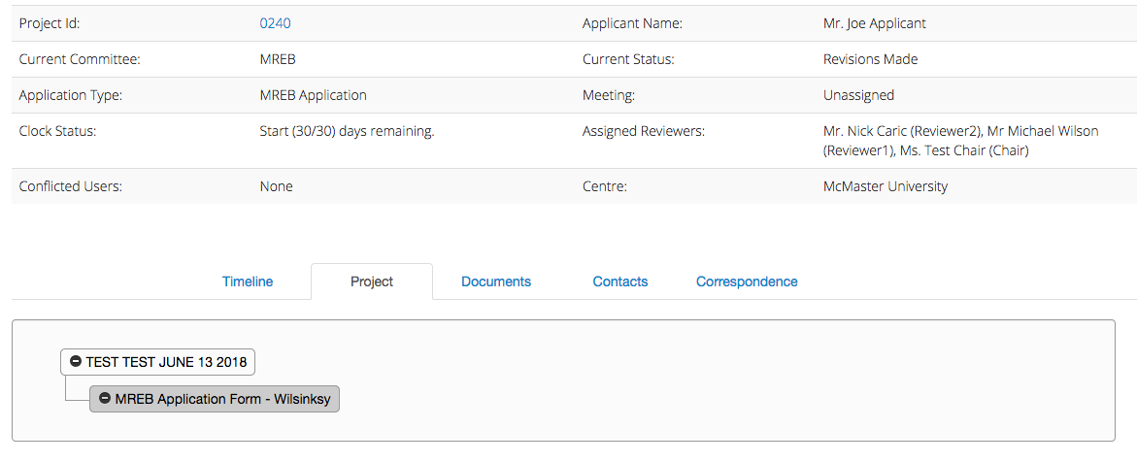
Project

A very important point would be that after you access the letter and download a copy, if you want, you need to go back to “project”, top of the tree, and then click on the most recent submission to access the one with the revisions. Otherwise you are still in the superseded application.

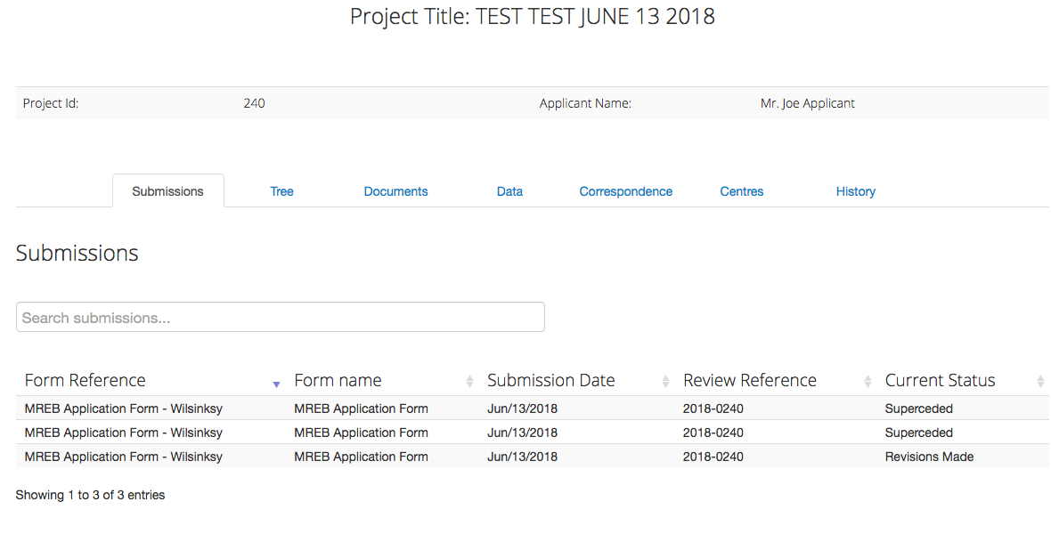
Most Recent Version
Click

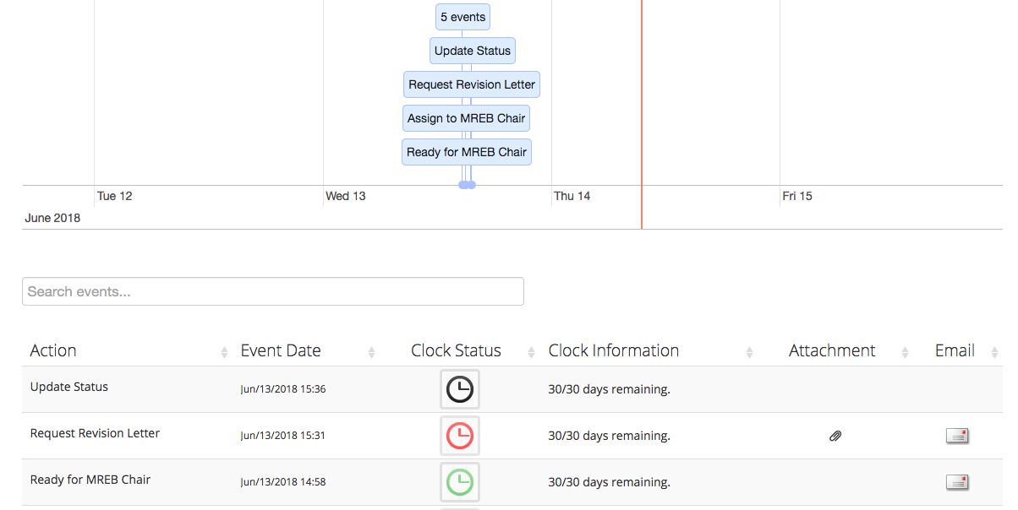
Chair letter
Chair letter

Attachments or letters can also be accessed by clicking on a Timeline Event, as this image of such an action illustrates:
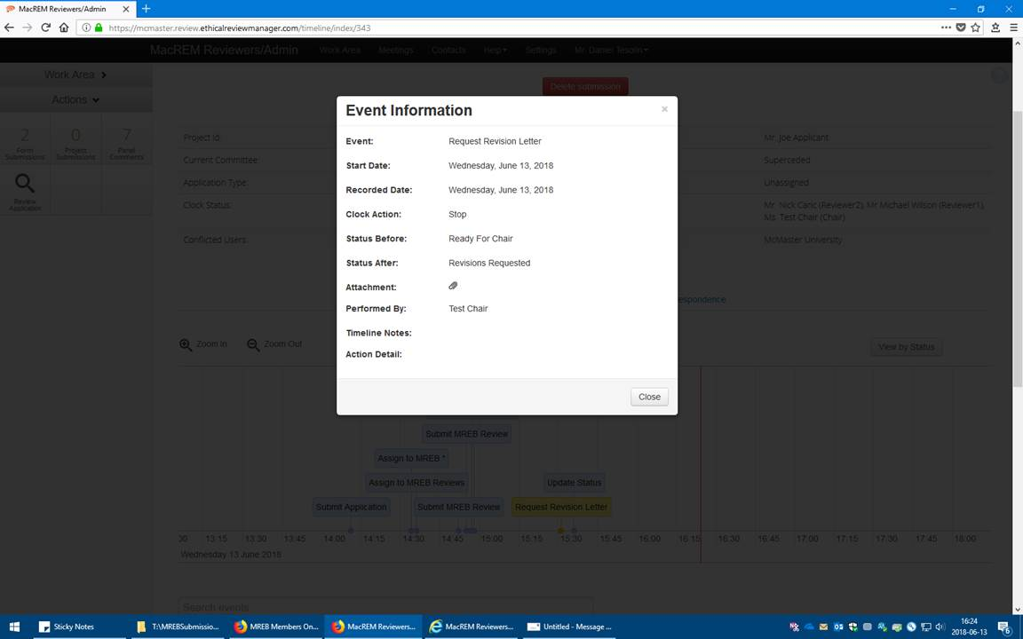
Chair letter

